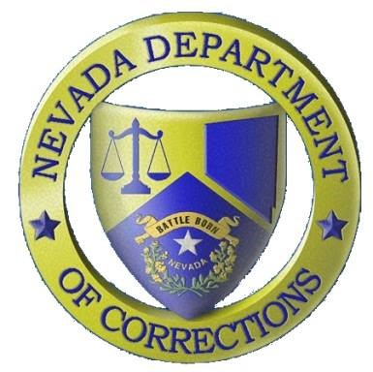
Nevada Department of Corrections

Public Information Office: 775-887-3309
PIO Scott Kelley Cell: 775-350-0037

Press Release
For Immediate Release:
July 25, 2019

The Nevada Department of Corrections (NDOC) reports that on Tuesday, July 23, 2019 at approximately 6:10 AM, Inmate Stephen Lutz (#1201809) died in the infirmary of High Desert State Prison north of Las Vegas, NV. Lutz, a 65-year-old male, was a Clark County commit serving 12-to-48 months for transport of a controlled substance. Lutz arrived at the NDOC on July 26, 2018. Lutz had a “do not resuscitate” order and several health ailments. No foul play is suspected in his death. An autopsy will be scheduled per NRS 209.3815. Lutz did not have any next-of-kin on record.
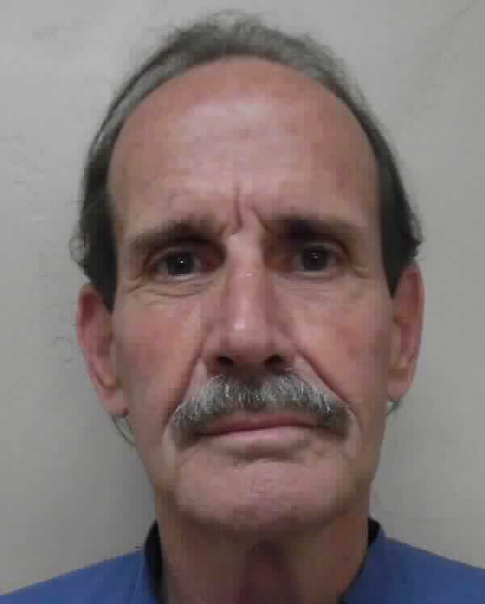
Stephen Lutz

